CLOUD APPLICATION DEVELOPMENT

Project Design Phase -2

Data Flow Diagram & User Stories

|  |  |
| --- | --- |
| Date | 27 0ctober 2022 |
| Team ID | PNT2022TMID45523 |
| Project Name | Customer Care Registry |
| Maximum Marks | 4 Marks |

Data Flow Diagram:

A Data Flow Diagram (DFD) is a traditional visual representation of the information flows within a system. A neat and clear DFD can depict the

Right amount of the system requirement graphically. It shows how data enters and leaves the system, what changes the information, and where data is stored

User Stories:

A User Stories is the about the product using after

Experience of the table of the story always elaborates

An advantage for the user, customer or user

Data Flow Diagram:

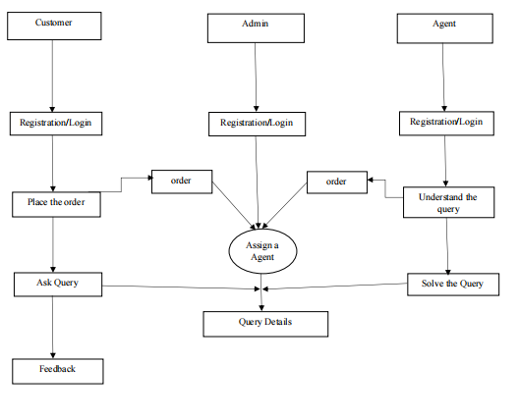

User stories :

Use the below template to list all the user stories for the product

**User Stories :**

|  |  |  |  |  |  |  |
| --- | --- | --- | --- | --- | --- | --- |
| **User Type** | **Functional**  **Requirement** | **User Story**  **Number** | **User Story** | **Acceptance criteria** | **Priority** | **Release** |
| Customer  (Mobile user) | Registration | USN-1 | Use the below template to list all the user stories for the product. | I can access my account /  dashboard | High | Sprint-1 |
|  | login | USN-2 | As a customer, I can log in to the application  by entering the correct email and password. | I can access my  account/dashboard. | High | Sprint-1 |
|  | Dashboard | USN-3 | As a customer, I can see all the orders  raised by me. | I get all the info needed in  my dashboard. | Low | Sprint-2 |
|  | Order creation | USN-4 | As a customer, I can place my order with  A detailed description of my query | I can ask my query | Medium | Sprint-2 |
|  | Address Column | USN-5 | As a customer, I can have conversations  with the assigned agent and  get my queries clarified | My queries are clarified. | High | Sprint-3 |
|  | Forgot password | USN-6 | As a customer, I can reset my password  with this option in case I forgot my old  password. | I get access to my  Account again | Medium | Sprint-4 |
|  | Order details | USN-7 | As a Customer, I  can see the current  status of orders. | I get a better  understanding | Medium | Sprint-4 |
| Customer  Care Executive | Dashboard | USN-8 | As a customer care Executive ,I  Can resolve a complaint registered by user | I can provide solution to a problem | High | Sprint-1 |
| Administrator | Registration | USN-9 | Asan admin, I can register the application by  entering my email, password,  and confirming my password. | I can access my account/dash  board | High | Sprint-1 |
|  |  | USN-10 | As an admin ,I will receive confirmation email once  I registered for the application | I can receive confirmation email  & click confirm | High | Sprint-1 |
|  | Login | USN-11 | As an admin I can log into  The application(admin panel)by entering email&  password |  | High | Sprint-1 |
|  | Dashboard | USN-12 | As an admin ,I can update the status of the complaint  to the user with the help of  Customer care executive. | I can satisfy the customer on  his/her query. | Medium | Sprint-2 |
|  |  | USN-13 | As an admin , I can logout from  The application | I can logout from  The application | Low | Sprint-2 |
|  | LOGUT |  | ADMIN OUT | APPLICATION | LOW | Sprint-2 |